Code Summary user story 1

For the user story one, i placed the theatre vertigo logo under the navbar by centering it through CSS. Created two un-equal columns to place the Spotlight, donations and sponsor sections in them with images. Finally, added the land acknowledgement section at the bottom. The CSS had to be formatted to for a better layout and structure.

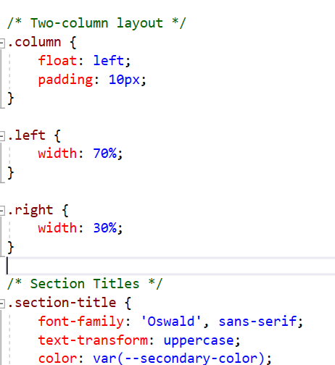

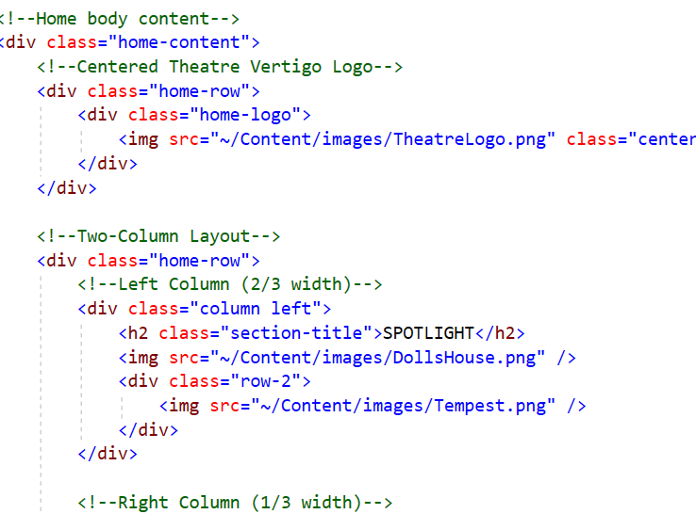

User Story 2

* The code defines the structure for a "SignIn" page in an ASP.NET Core MVC application.
* It uses jQuery to count the number of developers listed on the page and dynamically updates a Bootstrap badge with this count next to the "Developers Of TheatreCMS" title.
* The list of developers is displayed in a series of <p> elements within a div with the ID PersonList.
* The user's name is added to the list of developers at the end.
* When the page loads, the script counts the number of <p> elements and updates the badge with the total number of developers.

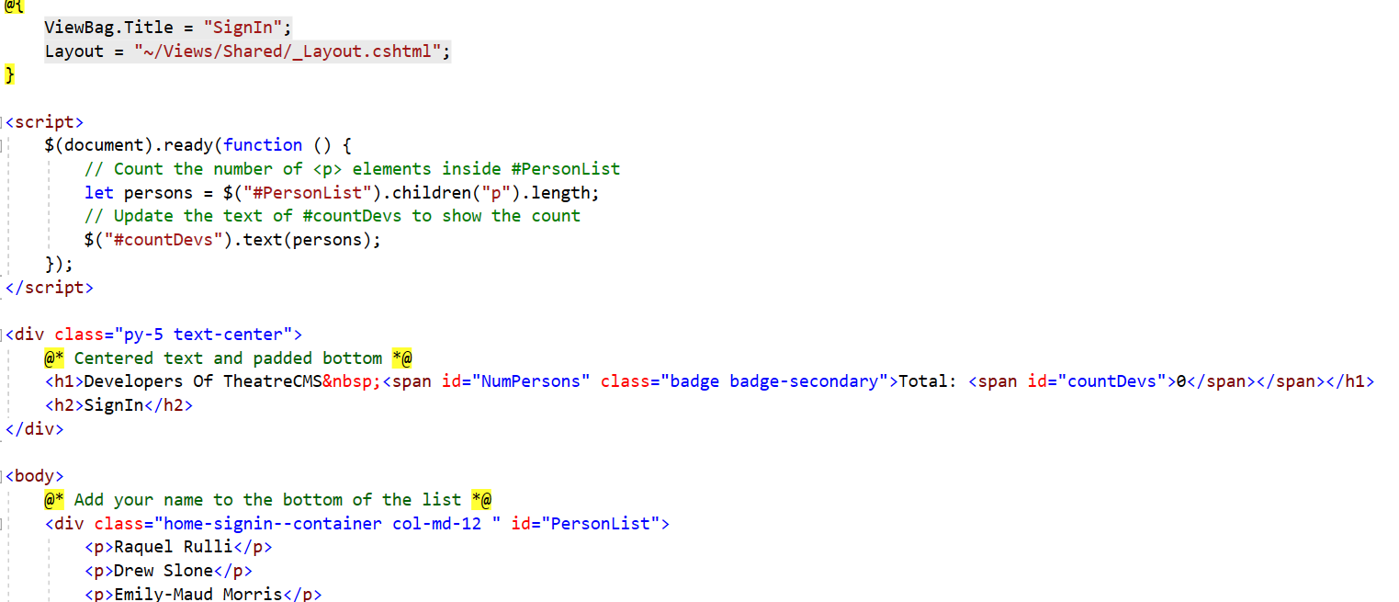

User Story 3

Created a BlogAuthor model for managing blog writers/authors in a theatre project, scaffolding the CRUD pages using Entity Framework and Visual Studio, and ensuring integration with the existing database and layout page.

